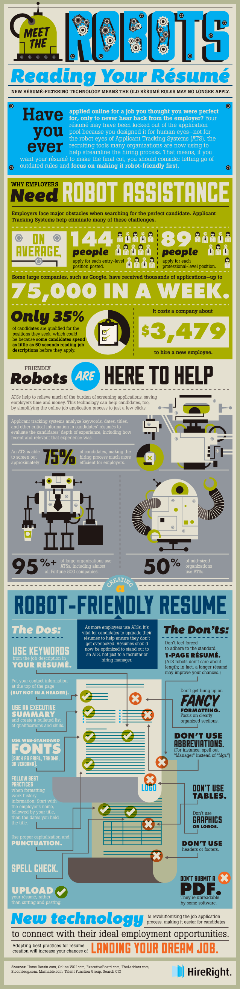

**How To Impress The Robot That's Reading Your Resume**

[**Vivian Giang**](http://www.businessinsider.com/author/vivian-giang) **Nov. 6, 2013, 7:41 PM 9,539** [**2**](http://www.businessinsider.com/how-to-format-an-effective-resume-2013-11#comments)

Many companies use some kind of [screening process](http://www.businessinsider.com/formatting-rules-to-get-your-resume-through-the-scanning-software-2013-2) to identify who they think are the right candidates.

Employee screening services provider HireRight found that 95% of large companies (including the Fortune 500 companies) and 50% of mid-sized firms use applicant tracking systems to analyze keywords, dates, titles and other pertinent information on an applicant's resume.

How do you get your resume past this automation process? HireRight says there are some rules you need to know.

**DO**:

* Use keywords from the job description.
* Put your contact information at the top (but not in a header).
* Use an executive summary and bulleted list of qualifications and skills.
* Use web-standard fonts such as Arial, Tahoma, or Verdant.
* Always upload your resume into the system rather than copying and pasting.

**DON'T**:

* Feel forced to adhere to standard one-page resume.
* Use fancy formatting.
* Use abbreviations.
* Use any tables or charts.
* Use graphics of logos.
* Don't submit a PDF (They're unreadable by some software).

Below is an [infographic created by HireRight](http://www.hireright.com/blog/2013/11/meet-the-robots-reading-your-resume-infographic-ats-recruiting/) that tells you what you need to know about the new resume filtering technology.